**ENHANCING SECURITY AT SJSU**

**BY**

**TUSHAR SINGH**

**SAMARTH BHARGAVA**

**PRIYANKA DUTTA**

**TOUSIFUR RAHMAN KHAN**

**ABSTRACT**

The objective of this report is to analyze the current security system in and around San Jose State University and come up with a better system or product as an enhancement to the prevailing system. Surveys have been conducted to acquire customer needs. We have used various tools and techniques of Systems Engineering in the development of a new product that will work along with UPD services to make the campus and its surroundings more secure for the students, faculty and facilities staff. Quality Function Deployment (QFD) has been used to identify and manage design trade-offs and customer requirements. Analytical Hierarchy Process (AHP) has been used for decision making analysis to choose the best alternative. Moreover, to come with a system/product for better security services, we have used various system characteristics, design and construction, logistics analysis and cost analysis. Thus, this product will serve to be an enhancement to the current security services and reduce existing crimes in the campus as well as its surroundings

Contents

1.0 SCOPE 5

1.1 INTRODUCTION 5

2.0 Applicable Documents: 5

3.0 System Requirements 5

3.1 System Definition: 5

3.2 General Description: 5

3.3 Operational Requirements (Need and Mission) 6

3.4 Identification of specific needs/requirements for our system: 6

3.5 Technical Performance Measures: 7

3.6 System Trade off Analysis 8

3.7 Conceptual System Design 9

3.7.1 Functional Flow Block Diagram (FFBD) 9

3.8 Market Demand Feasibility 10

3.9 Technical Feasibility 10

3.10 Cost Feasibility 11

3.11 Functional Analysis and Allocation 11

3.12 Allocation of Requirements 11

4.0 SYSTEM CHARACTERISTICS 12

4.1 Performance characteristics 12

4.2 Physical characteristics 13

4.3 Reliability 13

4.4 Maintainability 13

4.5 Usability (Human Factors) 14

5.0 DESIGN AND CONSTRUCTION 14

5.1 Material Process and parts 15

5.2 Mounting and Labelling 15

5.3 Safety 15

5.4 Workmanship and Craftsmanship 15

5.5 Testability 15

5.6 Economic Feasibility 16

6.0 DOCUMENTATION DATA 16

7.0 LOGISTICS 17

7.1 Maintenance Requirements 17

7.2 Supply Support 17

7.3 Personal Training 17

7.4 Producibility 17

7.5 Disposability 17

7.6 Affordability 18

8.0 TEST AND EVALUATION 18

9.0 QUALITY ASSURANCE PROVISIONS 18

10.0 DISTRIBUTION AND CUSTOMER SERVICE 18

11.0 MATERIAL RECYCLING DISPOSABILITY AND REQUIREMENTS 19

12.0 CONCLUSION 19

13.0 DISCUSSION 20

References 21

APPENDIX 22

**List of Figures and Tables**

**Figure 1**: Analytical Hierarchy Process Tree

**Figure 2**: Functional Flow Block Diagram (FFBD)

**Figure 3**: Context Diagram

**Figure 4**: Device Parts

**Figure 5**: ISHIKAWA Diagram(Fishbone)

**Figure 6:** System Components in series and parallel

**Figure 7:** House of Quality

**Table 1:** AHP tradeoff analysis

**Table 2**: Survey Results Summary

**Table 3**: Relationship Matrix

**Table 4:** Normalized Matrix

**Table 5**: Failure Mode and Effects Analysis (FMEA)

# 1.0 SCOPE

## 1.1 INTRODUCTION

The system we have selected in this project is the current security system in and around San Jose State University campus. The main reason behind selecting this system is the increased crime rate around the campus and a demand for a more reliable system.  The scope of this system concentrates mainly on safety and how individuals associated with San Jose State University (students, faculty and facility staffs) feel about the current safety system in the campus and also, what new system or product needs to be introduced to make the campus safer during the later hours of the day. Our main objective is to create a better system that has high probability of success rate of making the campus and its surroundings more secure than the current one. The system design is being created with a broad view keeping in mind all the requirements and suggestions that we have collected by conducting a survey.

# 2.0 Applicable Documents:

The following documents were essential and applicable while designing the system-

* **UL Standard of Quality** is a standard-setting organization, combining extensive safety research, scientific expertise and uncompromising focus on quality to help create a safer world. [1]
* **ISO 14000** is a family of standards related to environmental management that exists to help organizations minimize how their operations negatively affect the environment.[2]
* Using **ISO 9001:2015** helps ensure that customers get consistent, good quality products and services, which in turn brings many business benefits.[3]
* **Lean Six Sigma** is a methodology that relies on a collaborative team effort to improve performance by systematically removing waste and reducing variation.[4]

# 3.0 System Requirements

## 3.1 System Definition:

This section contains general project description, functional features, method used to acquire needs of customer, technical requirements for a new design system and a decision tool to select the best alternative among those provided.

## 3.2 General Description:

People associated with San Jose State University often complain about crimes that occur mostly during late hours of the day like theft, robbery or being confronted by unknown assailants. Although the security system inside the campus is quite satisfactory, but there has been a number of incidents where people have been robbed off their belongings despite of the various security provisions inside the campus and round the clock surveillance provided by UPD. As a result, various individuals were never able to retrieve their belongings. The assailants fled from the scene immediately or sometimes the UPD arrived late on the scene. Moreover, there had been many incidents where people never complained to UPD about their confrontation with assailants as they did not attempt robbery but there were cases of harassments. The UPD were not able to respond quickly, as the victims did not have any means to alert them and had to travel to a point where an emergency blue lights is located inside campus. Therefore, our group has focused on resolving these issues and have tried to introduce a product which will decrease the response time of the UPD after the incidents have occurred and also by increasing security inside the campus and its surroundings.

## 3.3 Operational Requirements (Need and Mission)

In order to become aware of customer needs, we conducted a survey to know what they think about the current security system in and around the campus and if they are satisfied with the current system. Open ended questions were asked about their needs for a security system here in the campus and areas surrounding the campus. There were multiple questions about confrontation of people with unknown assailants if any and what measures were taken by them after they were confronted by the same. We also inquired whether the measures taken by the authorities were in accordance to what the victim expected, or did he/she expect more. Our survey concentrated on the various security services including UPD accessibility inside the campus during all hours of the day and also how safe people feel, if they have to stay for late night studies on campus like in the library. One of the main issues that we’ve included in our survey is the transport communication from campus to students, faculty and facility staff’s homes and how safe it is around the campus if one has to walk down during dark hours from campus, as many incidents have been reported till date about robbery and other crimes in the neighborhoods of the campus. After the survey we came to a conclusion that people need the security system to be more reliable and make the campus and its surroundings safer mostly during night hours.They expect a well-designed and effective system that will help them communicate with the UPD immediately if confronted with a situation with assailants such that these incidents don’t occur and hence people feel more secured when staying back late in the campus. Therefore, our mission is to design a product that will enhance the current system and thus provides a solution for the above-mentioned issues to meet customer needs.

## 3.4 Identification of specific needs/requirements for our system:

We covered almost every concern an individual face when it comes to talking about a secured campus. We included questions in our survey which was associated with the requirements for the system and accordingly we received feedbacks and suggestions from students and faculty.

System Needs were identified as:

**Better Surveillance**- Although SJSU provides utmost security to its students and staff inside the campus, we tried to determine if this can be improved by conducting better 24/7 surveillance by the authorities to make the campus more secured as students stay during late hours in the campus.

**Faster Response Time from the University Police Department**-   We needed to know if responses from UPD was fast enough after an incident had occurred and if that response time was enough to catch a hold of the criminal after the crime was committed.

**Alert system**- A system that provides an alert in case of an emergency situation was needed by the participants of the survey. This need comes as a suggestion from the results of the survey.

**Notification to UPD/SJPD-** A system that provides immediate notification to the concerned authorities and reduces the response time of the action by the authority.

**Anti-theft Mechanism-** A feature to secure the personal belongings of a person was a must for many. Thus, a feature to provide an anti-theft mechanism was also identified as a need and is strived to be fulfilled.

## 3.5 Technical Performance Measures:

The Quality Functional Deployment (QFD) was applied to the system. We completed the QFD on basis of responses and identified the system requirements. The QFD can be referred to in Appendix. The top responses included the following-

**GPS Connectivity-** Although SJSU provides utmost security to its students and staff inside the campus, we tried to determine if this can be improved by providing a constant GPS connectivity to the individuals for their items to be tracked if wanted to make the campus more secured as students, faculty and the facilities staff stay during late hours in the campus.

**Immediate Notifications to UPD (via Application) -** We needed to know if responses from UPD were faster after an incident had occurred and if that response time was enough to catch a hold of the criminal after the crime was committed. This can be significantly reduced if an immediate notification is sent out to the concerned department saving some crucial minutes.

**Emergency Siren-** Many a times when a student is robbed he/she is in an isolated place where no help can be found during that time. We decided to include a mechanism that when triggered a high pitch siren from the device is emitted to scare off the assailant and create awareness in the nearby surroundings for the emergency situation.

**Unhindered and Reliable UPD emergency services-** We wanted to know if the calls that students make to the UPD after an incident has occurred and are they unhindered or unobstructed and if there is quick response from UPD and if there is any scope of improvement for a more reliable UPD service.

**Security Hooks/Straps-** In order to increase security for personal items a mechanism to include security hooks/straps is included which requires a unique key to get pass through it.

## 3.6 System Trade off Analysis

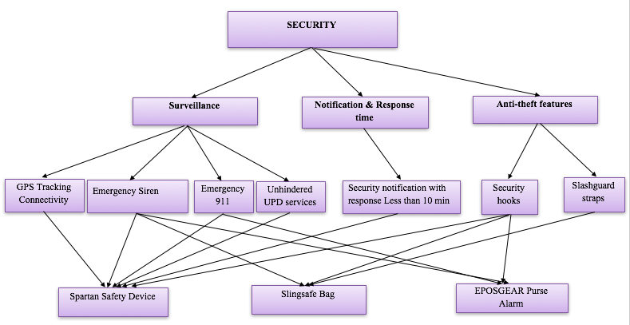

**Figure1**: Analytical Hierarchy Process Tree (AHP)

The system trade off analysis is used for selecting and evaluating different available alternatives. After collecting and analyzing survey data and brainstorming together as a team, we divided the system needs that satisfies customer requirements into three subsystems.

Since we knew what type of system we had to work upon after the survey results, hence among all the provided subsystems, we decided to use Analytic Hierarchy Process (AHP) multi criteria decision making system, and compared the criteria under the 3 subsystems. The criteria were compared to choose the most demanded need of the system. This was done so as to choose the areas where we will be focusing and working on. The alternatives we had to choose from were

* GPS Connectivity
* Emergency Siren
* Emergency Notifications to UPD/911
* Unhindered and Reliable UPD emergency services
* Security Notification and Faster Response time (An Application)
* Security Hooks/Straps
* Slash guard Strap bags.

The AHP process included comparisons between all 7 subsystem criteria. The comparisons were made on the basis of importance of one criterion over the other.  The criterion with Equal Importance was given 1-point, Moderate Importance 3 points, Strong Importance 5 points, Very Strong Importance 7 points and Extreme Importance 9 points. For example, we believe faster response time is extremely important over emergency sirens, this idea was derived from the survey as most of the time, response time was late, and the accused were never caught. Similarly, the notifications of threat around the crime scene hold very strong importance over Slash guard bags as the students nearby a crime scene should always be asked to stay away from the area of crime. The calculation for AHP is included in the Appendix.

Based on these criteria the respective weights of importance were found.

|  |  |
| --- | --- |
| **GPS Connectivity** | **22.6%** |
| **Emergency Siren** | **13.4%** |
| **Emergency Notifications to UPD/911** | **20.3%** |
| **Unhindered and Reliable UPD emergency services** | **20.7%** |
| **Security Notification(via Application) and Faster Response time** | **12.5%** |
| **Security Hooks/Straps** | **8.5%** |
| **Slash guard Straps bags.** | **2.0%** |

**Table1:** AHP tradeoff analysis

After looking at the trade-off analysis, in order to fulfill these needs for the new system we have proposed a new product/device, which will help an individual to make immediate communication with the UPD as well as 911 in the event of any unlikely situation that they encounter during any time of the day or night. This product will trigger a help signal to UPD and 911 and thus help them to immediately respond and be at the scene in comparatively lesser time. The device will provide GPS connectivity which will be maintained and closely monitored from a control center. On activating this device, a siren will be initiated that would alert people in the surrounding areas about any crime happening in the area. This will also trigger a message sent to UPD/911 from the victim's device via an application installed prior in their cell phones. Furthermore, this device will allow tracking and if an individual gets robbed off their belongings, the authorities can track it directly to the assailant because of the presence of a GPS tracker.

## 3.7 Conceptual System Design

### 3.7.1 Functional Flow Block Diagram (FFBD)

A functional flow diagram is a multi-layered step by step flow diagram which is also time sequenced. An FFBD breaks down system requirements into subsystems. Functional model provides an idea of the functions that system will perform. These diagrams do not explain how these functions are implemented.

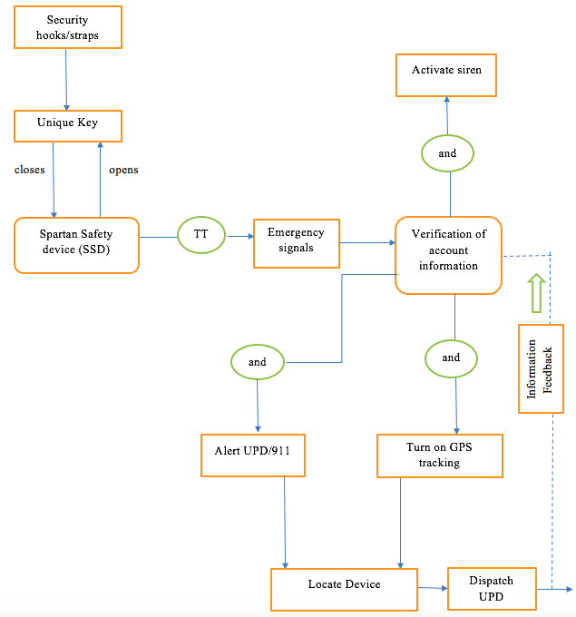

**Figure 2**: Functional Flow Block Diagram (FFBD)

## 3.8 Market Demand Feasibility

In order to determine the market demand, the preferred method would be to trend the exact number of devices in various use and technical categories and hence to figure out where our product fits. Due to high performance technical aspects involved in our product and lack of funding, we are expecting San Jose State University to subsidize our product so that the market demand of our product is increased. Based on our research and data received via sources on the internet (Researchnester.com), it cites that USA captured the largest market share of North America anti-theft bags, Sling Safe (one of our competitors) in 2016 and this demand is expected to rise in the coming years. This information that we have extracted falls in the exact market segment our product is trying to reach by being more reliable and also user friendly in terms of technical aspects and portability.

## 3.9 Technical Feasibility

Keeping in mind existing technologies in the system, we have designed our product by integrating them in a way that is strongly aligned with specific customer needs. We have integrated the technical aspects of GPS tracking and high pitch siren into a lock that can be used with any kind of backpacks that an individual carry on a daily basis. This lock consists of a battery/cell and a security hook/straps that can be attached to any bag. On activating this lock by triple tapping on it, it activates the GPS tracking, initiates a high pitch siren that alerts people in the surroundings and sends immediate signals to UPD and 911. Summarizing, all these technical features are integrated into one product and thus the technical feasibility of our product is considered very high.

## 3.10 Cost Feasibility

We will be applying a bottom up approach to come up with the cost for our product. Also,  keeping in consideration the major areas involved in bringing this product into existence that determines the cost and also looking at the price ranges of competitor products, we will determine the total cost of our product. A detailed analysis of cost feasibility is given in the section called Economic Feasibility of our report.

## 3.11 Functional Analysis and Allocation

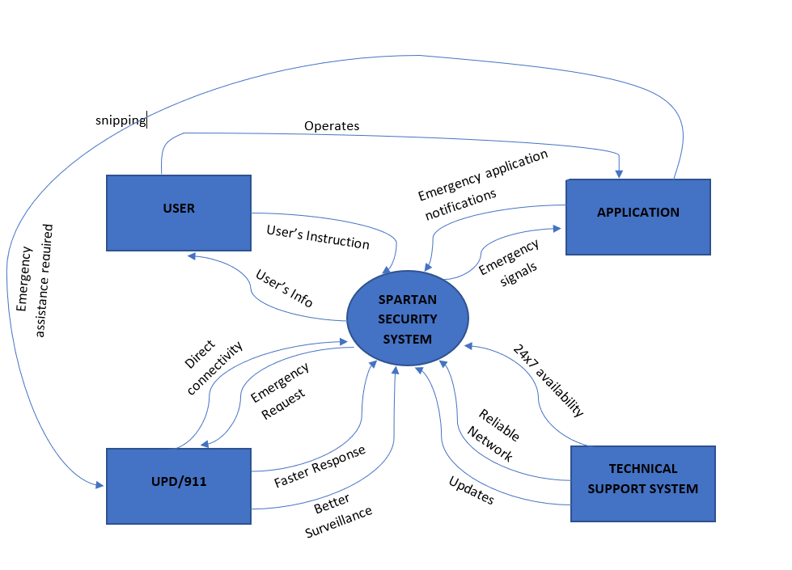

**Figure 3**: Context Diagram

The context diagram was applied to identify and analyze major system and its subsystems for our security system. In addition, the context diagram allowed us to identify what features of the system and how to apply them. The context diagram gave us the notion on how to develop connections and interrelations between our system and subsystem.

## 3.12 Allocation of Requirements

After Considering the QFD and context diagrams, many interrelated functions were found. The security system had mainly four terminator functions: User, Application, UPD and Technical Support System. The flow connected each of them to the security system. The interconnection acted as an input for one function and the output for the other. For example: The idea of emergency request made by the user in case of any emergency was followed back by a faster response time from the UPD or 911. Or the notion of emergency notification in surrounding area of the crime scene could be achieved by the emergency siren built in our safety device.

# 4.0 SYSTEM CHARACTERISTICS

## 4.1 Performance characteristics

The Safety device designed consists of four main parts:

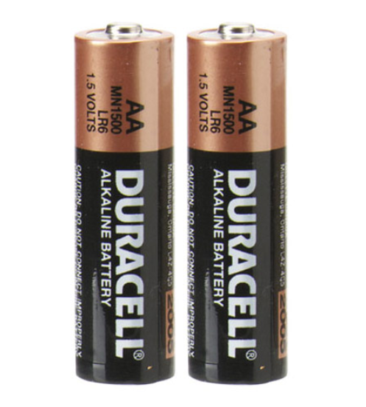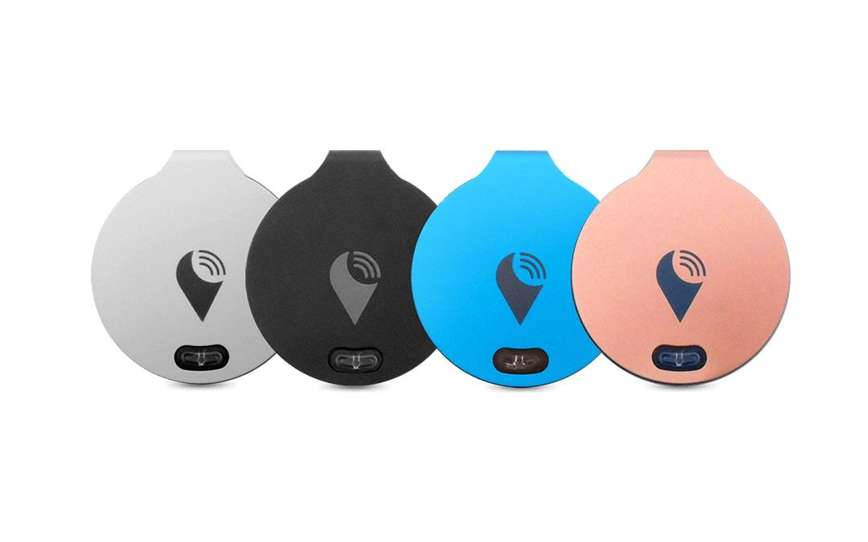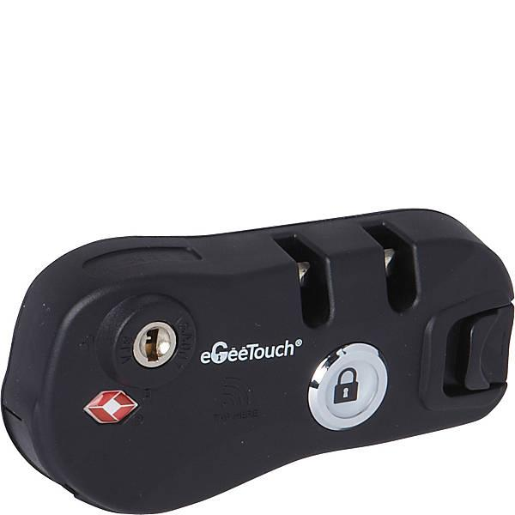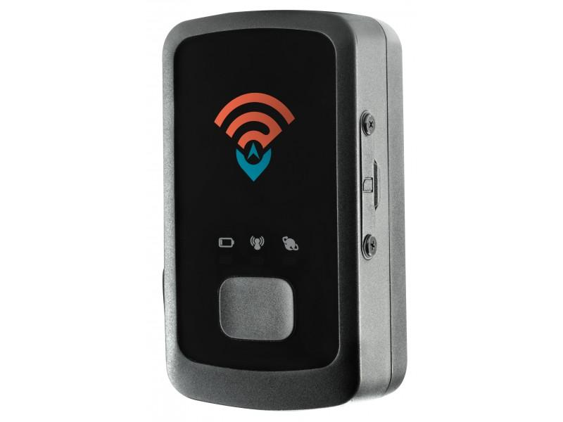

    Battery/Cell             TrackR Sirens Bag Chain Locks      GPS Tracker

**Figure 4**: Device Parts[7]

**Battery/Cell**

* Battery/Cells will provide a power of up to 600 mAh and voltage output up to 1.7 Volts which would be adequate for the mechanism of this device.

**Locking Mechanism**

* The device is made such that it can be attached to any bag. The hooks are made to remain attached to the bag permanently.
* The attachment is also made strong (with the help of clamping hooks on back) where it cannot be pulled out by manual pressure.

**Emergency Siren**

* The siren is present inside the device which can make a high pitch sound over 90 dB in case of triple tapping the emergency button.
* The sound emitted by the siren is of a frequency where it can be heard within a range of 50 meters.

**GPS tracking**

* A GPS tracking chip is attached inside the lock to make sure it gets activated on triple tap providing a constant surveillance of the belongings.

## 4.2 Physical characteristics

In case of a triple tap the device sends an automatic emergency signal to UPD and nearby 911 service via an application installed prior on the user’s mobile phone.

**Battery/Cell**

* These are single cell batteries. Their diameter is about 10.5mm and have a length near 44mm.
* Their small size and light weight would make them perfect to be used in this device.

**Locking Mechanism**

* The chain hooks have a special feature to lock the chains of the bag. The chains of the bag are locked by a special code known only to the owner.

**Emergency Siren**

* We decided to use TrackR sirens due to their small size and high performance giving us a more compact and portable device.

**GPS tracking**

* The lightweight design and compact size results in easy attachment to the device.
* The feature is mostly in off stage unless triggered which leads to low energy consumption.

## 4.3 Reliability

Reliability is the probability that a product will perform its intended function in a satisfactory manner for a specified time, when operating under specific conditions. The parameter that defines the reliability of the system include probability density function and hazard rate. The hazard rate is based on the bathtub curve which determines what distribution is closest to the data present. A increase and decrease in the curve represent that it follows a Weibull or Lognormal distribution while a constant curve represents an exponential distribution. This determines which model is a best fit for our data. We did the reliability analysis for our Spartan Safety Device focusing on two techniques- Failure Model and Effective Analysis (FMEA) and Ishikawa Diagram(Fishbone). Diagrams in Appendix.

## 4.4 Maintainability

The system should be maintained and serviced at regular intervals. Some things to keep in mind to keep the system running smoothly include a constant maintenance of its parts and replacement of the used-up parts. Replacement of parts like the battery/cells used for the siren needs replacement once out of charge. Lock needs to be kept in check for wear and tear damage and replaced if any fault is found. Siren should be connected properly to the mechanism and periodic checks needs to be administered by the user to identify any fault. GPS should point to an accurate location of the product.

4.5 Usability (Human Factors)

According to ISO 9241: Ergonomics of Human System Interaction Usability of a product is defined as the “Extent to which a product can be used by specified users to achieve specified goals with effectiveness, efficiency and satisfaction in a specified context of use.” Certain features of usability in our product are:

-A small and compact design of our device makes sure the user finds the device handy and portable.  
-Our design has features like siren and tracking ability built in the system. All of them getting activated by push of a single button thrice. This makes the design very user friendly as no complex method of operation is required.  
-The design having a simple hook mechanism for the locking is a standard device used throughout the world and is quite simple to be operated.   
-Our design has an easy way to change the parts, especially the battery used to operate the device. It uses a standard AA battery available almost everywhere thus increasing the usability of the device.  
-Our design uses a GPS signal having the band L2 following the L2C civilian code and the Military (M) code, making it compliant with the GPS frequencies available for public use.  
4.6 Supportability:

This section measures the degree to which a system can be supported both in terms of its inherent design characteristics of reliability, maintainability and the efficacy of the various elements of product support, to include the spare-part, tools, and training required to operate and maintain it. For our product we can provide spare battery as it is the most important part of our product driving all the other parts that are integrated together. Training video on how to use the device and a user manual along with the product will be available for the user to improve their experience. A mobile application is also provided alongside the device for the connectivity requirements.

# 5.0 DESIGN AND CONSTRUCTION

For the design of our project, we have followed the IDEO method. The first step in this process was conducting a survey to know the end user wants and needs rather than developing a product with the design that we alone thought was feasible. Once these basic needs and problems were understood, our team of four members took a week to come up with four individual designs. Once we came up with four independent designs, we sat together and discussed these designs and debated about the features in the four different designs. We listed the best features we thought were suitable for our product and thus came up with a final list of features that we have incorporated in our single end product design.

## 

## 5.1 Material Process and parts

The device is attached to the bag all the time. It is housed in durable plastic box made via plastic injection process. The battery, siren and the GPS tracking are placed inside the box while the lock is attached on top of it facing the zipline of the bag. The color of locks is such that it camouflages with the color of bag. The plastic injection tooling helps getting the desirable texture. Another item included inside the box is the multi layered circuit of the system.

## 5.2 Mounting and Labelling

The instruction of mounting will be included alongside the box. The details will provide the instruction of mounting the common hardware and circuitry. Labels will be present on each of the hardware to ease down the process. Each point in the circuitry will be numbered, which will make sure that wires are connected correctly in the circuit.

## 5.3 Safety

During the preliminary design of our product, we have identified that the system does not hold any safety issues. The product does not use high power source as it is embedded with a 600 mAh battery/cell.  Also, the product (the lock) will be hooked to the bags with a safety hook by securely tightening is to the bag that cannot be easily removed manually. We have kept in mind the basic aspects which usually cause hazards and thus designed our product in such a way that the hazard causing materials are not incorporated in our design.

## 5.4 Workmanship and Craftsmanship

Both Workmanship and Craftsmanship can be achieved through combining the design and control of the supplier. The supplier is expected to have necessary expertise to make the basic requirements needed for this product like the safety hooks that are strong enough to hold the lock permanently to the bag so that it cannot be removed by applying manual pressure. Also, the primary component of the product, that is the siren that turns on when a customer triple taps the button on the device, gives a feeling of high level of workmanship to the customer who uses it. In this product, craftsmanship comes into play as the technical components that are attached to this product are expected to work all the time. The failure of one component in the system cannot lead to the failure of the product as a whole.

## 5.5 Testability

This section of the report consists of the various tests that will be performed on the safety lock

1. Locking mechanism- Strength of the safety hook will be tested by pulling the hook without the unique key until a threshold is reached where the hook rips off the bag.
2. Emergency Siren- Triple tapping mechanism that we have used in our product will be tested that activated the device on triple tapping the button along with activating the high pitch siren.
3. GPS connectivity- GPS connectivity of the product will be tested at different range from inside and outside of the university campus to meet the accurate connectivity at longer ranges when required.
4. Battery/cell- Here, the life of the AA cell used will be tested to assure the amount of time they can be used in the product before changing to the next cell. This test would give us an accurate time period of the life of the cells that can work when the device is in active state.

## 5.6 Economic Feasibility

In order to determine the economic feasibility of the product, we have used a bottom up approach based on the various steps involved in the life cycle of a product. The categories mentioned below have been taken in reference from the lecture notes (Models for Economic Evaluation) and thus estimates from each category are used to determine the total cost.

1. Operation cost- An estimate has been made of the small group of 4 team members and control center, we have estimated around $500/month.
2. Product Distribution Cost- This part of the cost is completely fictional, that includes the product distribution cost to be $2/unit because the product is being sold only inside the SJSU campus.
3. Software cost- We have estimated a cost of $100 including software and support cost for the product. This is a onetime cost for the device.
4. Maintenance cost- We have designed the product with optimal maintenance strategies, hence we expect a minimal physical cost and it would be the customer’s responsibility to change the AA cells in the device whenever necessary. We will provide replacement for the safety hooks if necessary and also software maintenance for the GPS connectivity at a cost of $2 per user per month.
5. Test and Support Equipment- We have assumed these costs to be included in the product unit price by the supplier.
6. Training costs- The end user of the product are the customers who will be using this product for safety and user manuals will be provided along with the product and hence these costs are already taken care of.
7. Retirement and Disposal cost- We estimated a cost of $5/unit, since we would recycle and reuse end of life models.
8. Product Cost- Casing the product, attaching hooks and straps, cost of siren and GPS, is estimated at $60,000 one-time cost for 1000 units when unit cost is estimated to be $60

# 6.0 DOCUMENTATION DATA

A new document is made in terms of suppliers, quality, procedures for maintenance, safety and considering all other aspects of the product. They should go for approval to the Document Control Department. These procedures will come along with the user manual of the product.

The user manual section includes

1. Cover Page
2. Title Page
3. Preface containing the details of related documents and information to navigate the user manual
4. Contents page
5. Guide on using the main function of the product
6. Troubleshooting section including the possible faults that can occur in the product and how to fix them
7. FAQ
8. Contact details for further assistance
9. Glossary and an index for larger documents

The functions and use of the safety lock, the safety hook and straps attached to the bag will also be included in a step by step procedure. A basic tutorial will also be available on the company website for in depth understanding of the product.

# 7.0 LOGISTICS

## 7.1 Maintenance Requirements

The software maintenance for the product will be provided by the company, whereas hardware maintenance will be provided to customers depending on the warranty available during the particular time.

## 7.2 Supply Support

The primary supplier will be responsible for providing the correct and accurate supply of the product as scheduled and quantity agreed upon.

## 7.3 Personal Training

Public demonstration of the product will be given at stalls put up during events conducted inside the campus. Also, features and user guide will come along with the product package when bought by the customer.

## 7.4 Producibility

The key to developing our product with high producibility is to choose the correct manufacturing partner. It is crucial to choose a manufacturing partner who has manufactured similar products in the past. These manufacturers will also help determine and review the best method for the production and assembly process. For this product, we have to choose the correct material as it is a recyclable and reusable product. The type of hooks to be used in the locks should be stronger than the usual hooks to avoid manual detachment of the locks from the bags.

## 7.5 Disposability

One of the main objectives of this product is to reduce carbon footprints in the system. The base material used in our product is plastic. The plastic parts used in our devices will be decomposable and thus will also be recycled and reused to make new devices. Recycling bins will be placed inside the university campus where customers can drop their nonfunctional devices. These devices will have decomposed and further used in the manufacture of new devices.

## 7.6 Affordability

Affordability in system engineering is the tradeoff between the three aspects schedule, cost and performance. Once balance among these aspects are met, a system is said to be affordable. Affordability for cost must be met from the perspective of both customer and manufacturing company. Generally, affordability is maintained when the below mentioned three aspects from customer’s end are fulfilled

1. A customer can purchase a product whenever needed
2. The cost of the product is within the budget limit of the customer
3. The customer is satisfied with the performance of the product

The economic feasibility section gives a detailed report on the estimated cost of the product considering the cost of various aspects related to manufacturing and maintenance of the product.

# 8.0 TEST AND EVALUATION

For testing and evaluation of the system, we will need to evaluate different aspects of the product. The testing can be carried out by mock drills of triple tapping the emergency button. The response time from UPD and 911 is a crucial factor in determining the proper functioning of the system. These mock drills can help us find the ideal response time. The testing can also help in determining the range of siren and GPS installed in the system. The battery used in the device has to be long lasting. The device will operate at a particular voltage level. The device has to make sure that battery maintains that level.

# 9.0 QUALITY ASSURANCE PROVISIONS

The certificate of quality assurance compliance will be provided with the purchase of the device. The product will comply with ISO 9001, ISO14001, Quality Management System, FMEA, Lean Six Sigma, UL Standards of quality, and all other important standards. Beside these standards the product will also undergo extreme testing to prevent failure and stress.

# 10.0 DISTRIBUTION AND CUSTOMER SERVICE

The device being produced will be targeted at the mass audience at SJSU. Techniques of mass production will be used to reduce the product cost. It will be stored at a warehouse near SJSU to reduce transportations cost.

The distribution process of this device will be done through direct and indirect channels. Events hosted by SJSU students will have stalls and separate sections of promotion of the product. There will be a push by the product makers to get this device recognized by the university and get it subsidized. After a point of time the production process will follow historical trend for mass production.

24/7 Technical support is one of the main technical parameter of the device. We will also 24/7 customer support free of cost on a toll-free number, where the customer can register complaints associated with the device. We can reduce these number of complaints by adding a troubleshooting manual operation along with the instruction book.

# 11.0 MATERIAL RECYCLING DISPOSABILITY AND REQUIREMENTS

As mentioned in the previous section, one of the main objective of this device is to reduce carbon footprints in the system. The plastic parts used in our devices will be decomposable. They will also be recycled and reused to make a new device. There will be recycling bins installed in selected corners of the college where customers can dispose the nonfunctional devices. There will also be provisions where customers can trade a new device for an old one under special circumstances.

# 12.0 CONCLUSION

The whole idea of doing this project was to improve the current security system in and around SJSU. Without the help of Systems Engineering approach, it gets very easy to overlook critical design and system functions during any product development. Through different system engineering processes, we developed a product which enhances the level of security at SJSU.

Furthermore, our final product consists of a GPS tracking and siren system which solves the major system needs we found out from the survey. Apart from these features it also adds a wow factor which will enhance sales. Also, the effectiveness of the design is well supported by the concepts of maintainability, economic feasibility, sustainability, usability and more. While we understand that each of these concepts will require further analysis and explanation by experts, the proof and framework of concepts are well reinforced by outcomes of this report.

# 

# 13.0 DISCUSSION

Question- If this new product or system-improvement idea eventually does not work out, what do you think are the three most probable reasons?

The probable reasons that we think would lead to the failure of our product are

1. Hoax calls: Misuse or mishandling the product, like an individual triple tapping the button on the lock without probable or actual threat calls can lead to UPD responding to hoax calls and hence a waste of the valuable time of UPD.
2. Funding: In order to reduce the cost of the product, to make it cost affordable, it has to be manufactured in bulk quantity. Manufacturing bulk quantity of the product needs excessive funding which can be a reason for the failure of our product.
3. Excessive use of strength on locks: The safety hook for the product (lock) would be tested (up to a certain limit) under extreme conditions and would be strong enough to not be manually detached from the bag, although excessive strength on the lock would cause its detachment from the bag.

Question- What challenges did you encounter during the systems engineering development process?

Challenges encountered during Systems Engineering Development Process-

1. During requirement analysis: UPD already has a well-developed system for security in and around the campus. One of the challenges faced by our team during the requirement analysis was to come up with a better and enhanced system or product that would complement the existing UPD system.
2. During functional analysis: Our team came up with various alternatives for a better system or product that could be implemented to enhance the existing system. Hence, we had to tradeoff between various alternatives and we faced minimal issues with the tradeoff of certain alternate systems.
3. Reliability: One of the issues faced by our team was to figure out techniques to make the product more reliable. For example- On triple tapping, the system initiates the functions of GPS connectivity and Siren. Our team came up with solutions where there would be no instances that the siren does not go off. In making the product near to perfection where all the systems in the product work simultaneously, proved to be an issue for our team.

Question-Which tools that you learnt (taught in class or self-learning) helped you in your analyses?

Tools that helped in our analysis-

1. FFBD: To isolate all the functional sequences and hierarchy of the system by decomposing the major system into subsystems.
2. AHP: Decision making analysis to choose the best alternative
3. QFD: To identify and manage design tradeoffs and customer requirements, which were identified by conducting survey.
4. ISHIKAWA Diagram and FMEA: Determining the reliability of the system.

# References

[1] “*Standard Matters”*, Retrieved from <https://ulstandards.ul.com/standardsmatter/>

[2] “*ISO 14000”*, June 2015 Retrieved from <http://pioneerhumanservices.org/about/news-events/pioneer-industries-earns-international-environmental-certification>

[3] “*ISO 9001:2015”***,** Retrieved From <https://www.okuma.com/okuma-is-the-first-machine-tool-builder-to-earn-iso-90012015-quality-management-certification>

[4] “*Importance of Lean Principles”* , March 2017, Retrieved From <https://www.6sigma.us/manufacturing/importance-of-lean-principles-impact-on-your-business/>

5 Dr. Supreeta Ameen, Lecture Handouts “*Systems Engineering”*, Fall 2017, San Jose State University

6 “*Survey on Security System In and Around SJSU”* Conducted by Group 13 ISE 222, Fall 2017, San Jose State University

[7] Image Courtesy “*Pinterest”* Downloaded from https://www.pinterest.com

# APPENDIX

**SURVEY**

**Survey Dissemination:**

We posted a survey on many social networking platforms like Facebook and Whatsapp groups and various student websites and applications of San Jose State University and received over 110 responses for the same. Questions were designed in such a way that it contained almost all the safety concerned queries related to student safety and also feedback from the students if they had to suggest for further improvement in the system. We have been able to cover most of the queries that usually occur while talking about campus security and its improvements. We tried to reach as many audiences where we focused mainly on students currently studying at SJSU and also alumni of the university as current and alumni students are the best audience who can relate to the day to day environment in and around the campus and also the security system for the same. We tried to cover a large group of students and received valuable feedback and suggestions and their responses about how well organized and feasible our security system is and any improvement if necessary.

**Sample Size Calculations:**

**X** = (Z a/22 * P*(1-P))

CI2

**Sample size** = X*pop/(pop+X-1)

When pop=population=35000

CI=Confidence Interval= 95%

Z=1.96

P=sample proportion=50%.

**Sample size = 118**

The following Diagrams depict the reports and responses we received from our Survey.

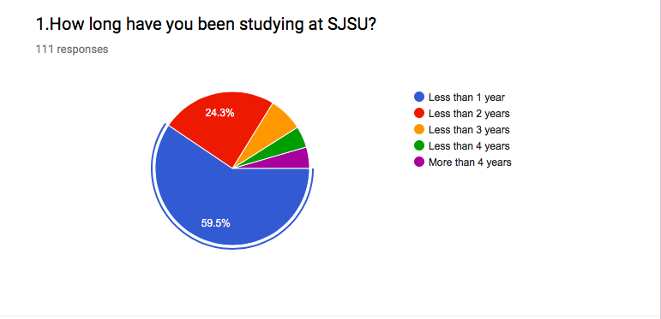

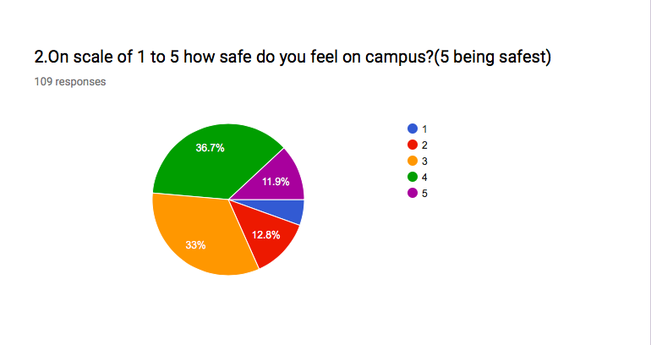

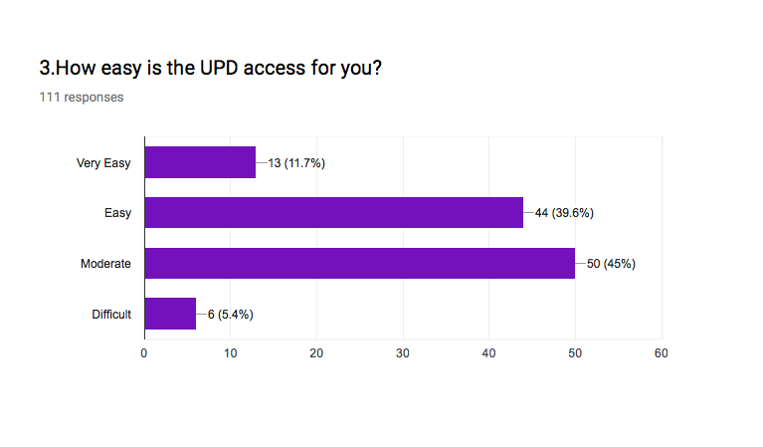

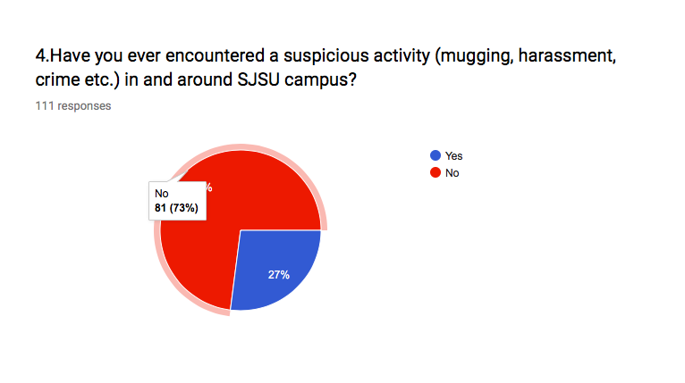

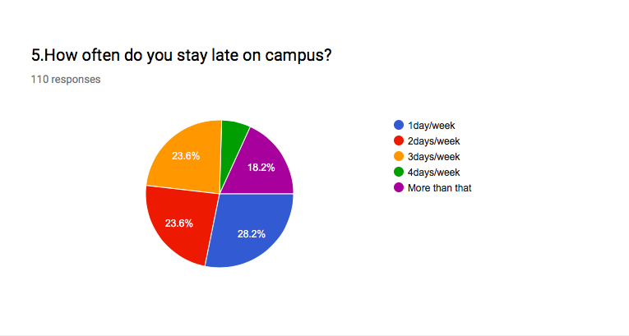

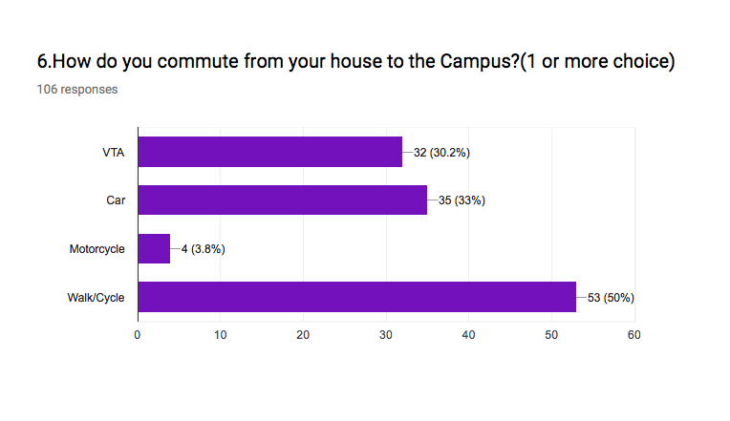

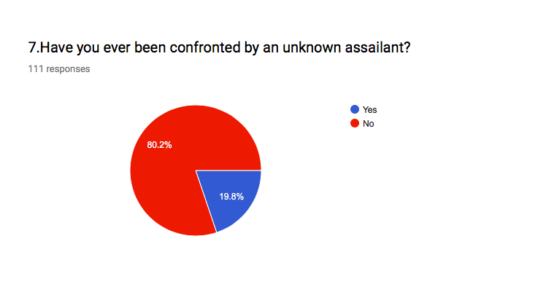

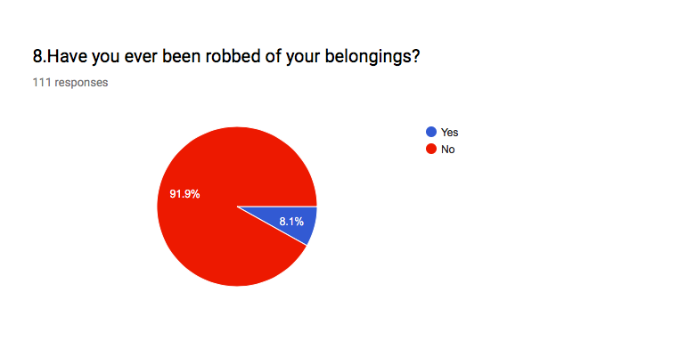

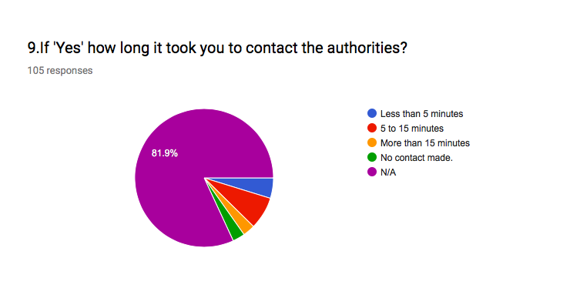

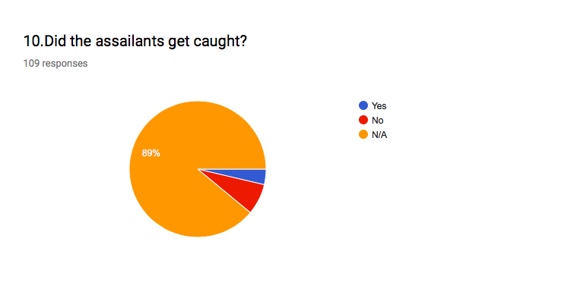

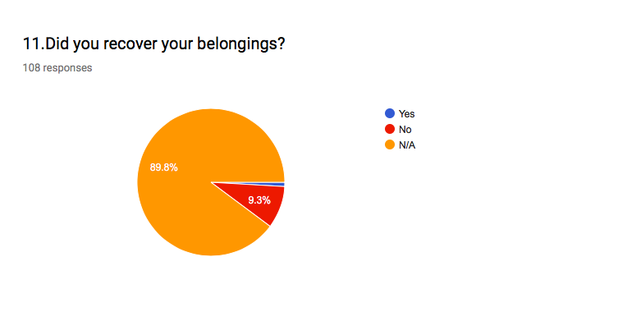

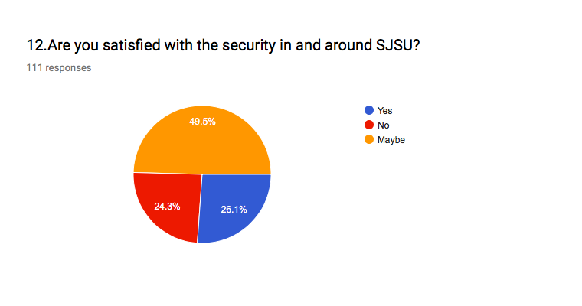

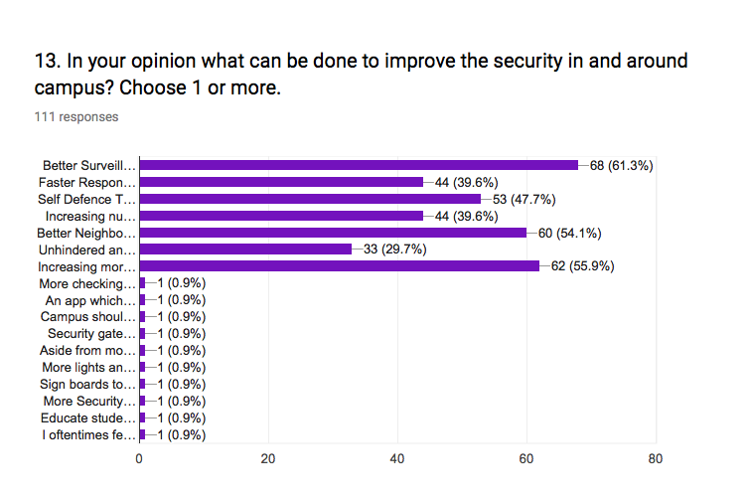

**Data Analysis from Survey:**



FIGURE

The data in Figure 1 suggest that almost 1/4th of the students have encountered activities like mugging, harassment, crime in and around SJSU campus.

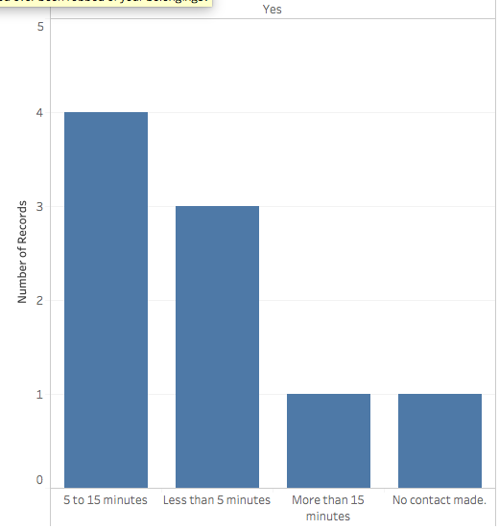

FIGURE

We can clearly see from the graphs in Figure 2 that if a student faces an emergency the response time from the UPD is more than 5 minutes in most of the cases, which is quite high for an emergency.

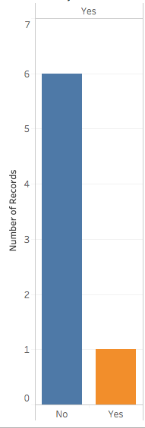

**Did you recover your belongings?**

**belongingsbelongings?**

FIGURE

In almost all the cases evident from Figure 3 the belongings lost by the student were never recovered by the UPD as there was no efficient tracking system for the same.



FIGURE

As we can see that only 26.1% of students say that they are satisfied with the current security in and around the campus, whereas 24.3% of the students are not satisfied with the current system. Also, 49.5% of the students do not have a strong opinion about the current security system. Since a greater no. of students is not satisfied, hence we can say that there is a demand for better security system in and around the campus.

**Survey Results Summary:**

At the end of the survey an open ended question was asked, “**In your opinion what can be done to improve the security in and around campus?**”

We summarized the customer needs specific to the responses we got:

|  |  |
| --- | --- |
| **Response** | **Response Count** |
| Better Surveillance | 68 |
| Faster response time from UPD | 44 |
| Self Defense Tutoring | 53 |
| Increasing number of Emergency Blue Lights | 44 |
| Better neighborhood nights watch | 60 |
| Unhindered and reliable UPD services | 33 |
| Increasing more security personnel | 62 |
| An application that sends emergency notifications | 01 |

TABLE2: SURVEY RESULTS SUMMARY

From these responses, we decided to work on improving the security in and around campus.

**AHP CALCULATIONS**

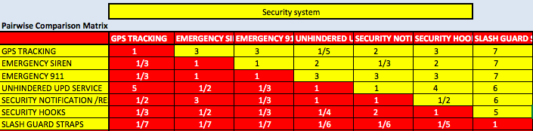

**Table3**: Relationship Matrix

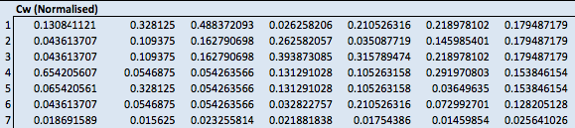

**Table4:** Normalized Matrix

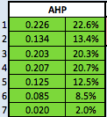

**Table5:** Weights

**RELIABILITY**

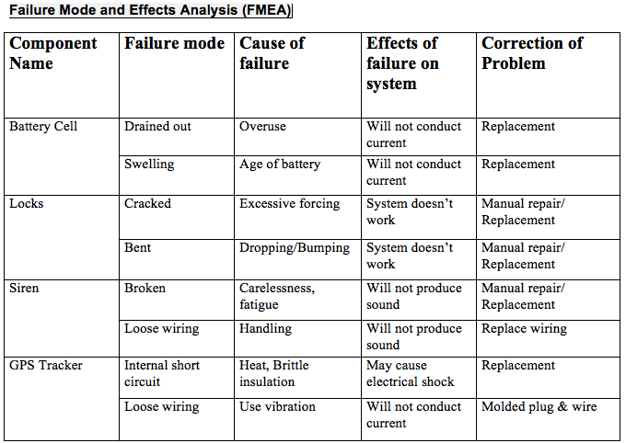

**Table6**: Failure Mode and Effects Analysis (FMEA)

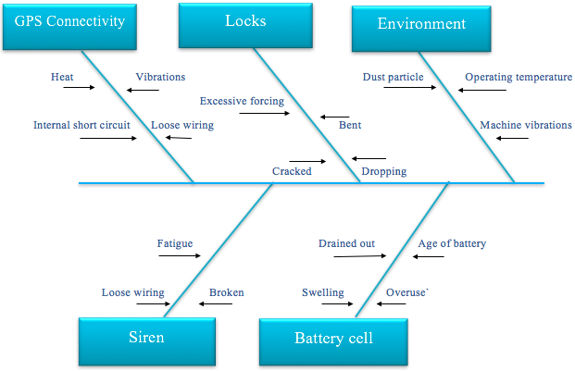

**Figure5**: ISHIKAWA Diagram(Fishbone)

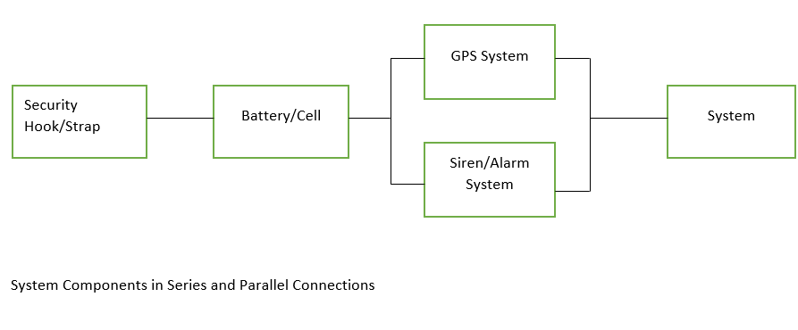

**Figure 6:** System Components in series and parallel

A close up of a map

Description generated with high confidence

Figure 7:House of Quality